Equipment upgrades and operation method
1、U disk upgrade
Please prepare the network upgrade package and usb flash drive
(1)3515[S][XM][WEB]_ZX_20130807.bin---Network model corresponding updates please select and equipment, if the corresponding error model will cause equipment upgrades is not successful, the network upgrade package please consult technical support or business.
（2）U disk(ordinary U disk)
Mode of operation
(1)Place the network upgrade package U in the packing list
(2)to ensure that the equipment in the running state
(3)Tell U disk inserted USB port to the device
(4)into the equipment/system management tool system upgrade/click on the corresponding updates
(5)Click on the upgrade, upgrade is complete equipment will be reset automatically
Note: please don't power off during upgrade, shutdown and affect the operation of upgrade. Wait for a few minutes, the upgrade is complete
- the network upgrade
Prerequisite: ensure network unobstructed in the local area network (LAN)
Mode of operation
- to obtain the IP address of the current device, system Settings/network Settings/IP address (please ensure there is no conflict in the LAN IP equipment)
- Use IE, 360 core IE browser, log in device, as shown in figure
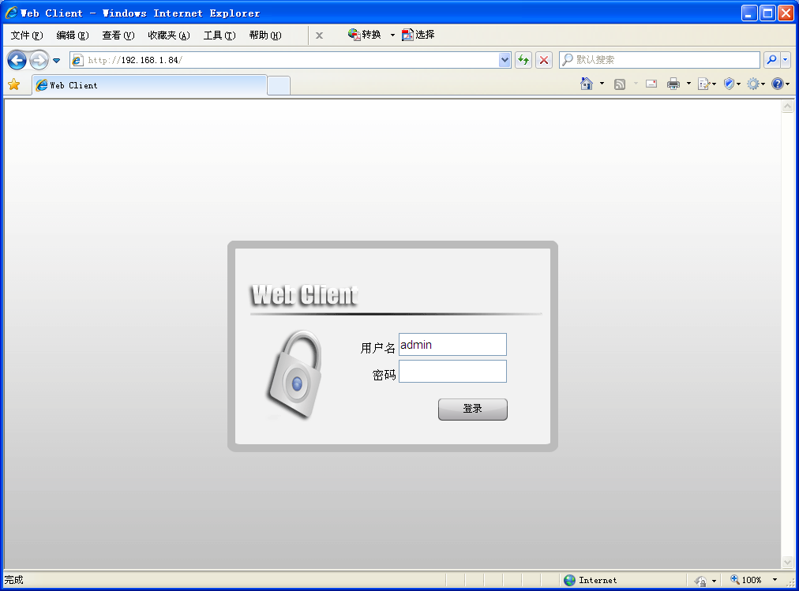
- login equipment, and enter the upgrade page, select network upgrade package upgrade.Device Settings/management tool/system upgrade, as shown in figure.
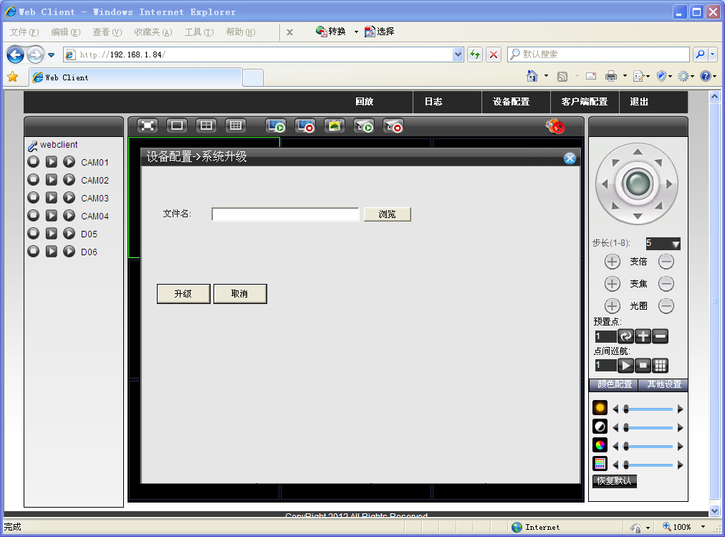
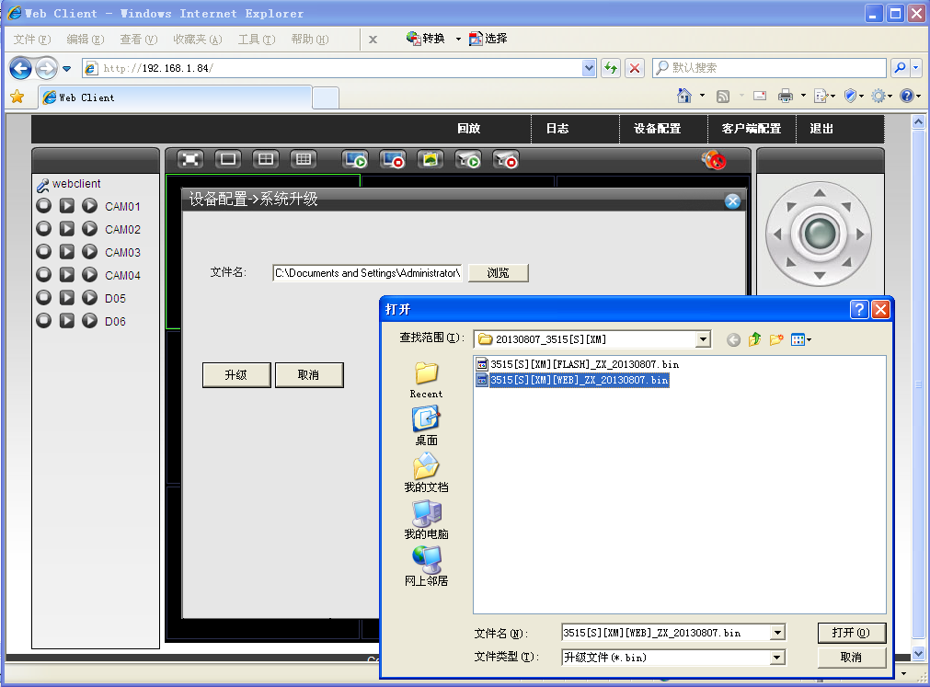
(4)click on the "upgrade" wait for a few minutes. To upgrade success!
Note: please choose the corresponding network upgrade packages to upgrade equipment, as well as during the upgrade, please don't power outages, shutdown and affect the operation of upgrade.
- Upgrade kits to upgrade
Premise:
- install the Upgrade tool: Upgrade. Exe, the installation package, please get from technical support
- to ensure that within the LAN network unobstructed, equipment IP does not conflict with other PC or device
Mode of operation
（1）Open the upgrade tool, search the IP equipment
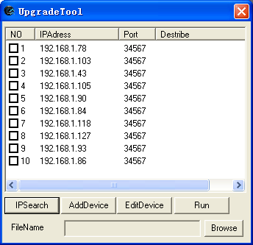
(2)check the corresponding equipment IP click on the "Browse" to select upgrade file
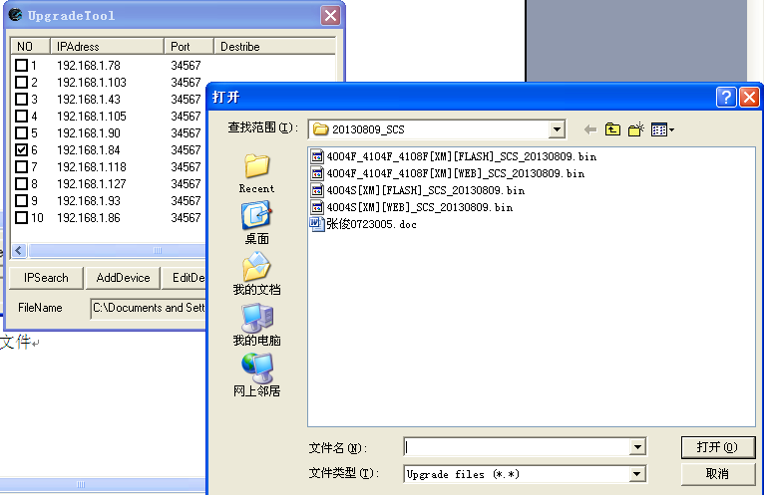
(3)click "Run" on equipment, confirm the user login and password, the default is empty, upgrade
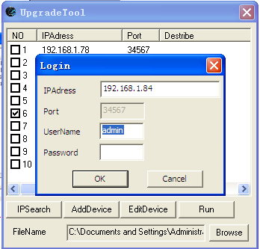
(4) click "OK" to upgrade, please wait for a few minutes, resistant to upgrade is complete.

